**Abstract of Paper for Oral or Poster Presentation in DDE2025   
Title in Times New Roman (12pt Bold) Using First Capital Letter**

***F. Author****1, S. Author2, T. Author1,2.   
(1) Institution, Department, City/Region, Country,* [*first_author_email@address*](mailto:corresponding.email@address)*. (2) Institution, Department, City/Region, Country*

The presenting author must be registered in DDE2025. Abstracts should be written in English. The use of this template is compulsory for the paper to be considered for presentation as contributed paper or poster. The abstract should not be longer than 1 page. Please, avoid using any non-standard abbreviations in the title. Abstracts can only be submitted electronically through the CMT Microsoft platform (link in the DDE2025 web-page for Submission). The body of the abstract should be in one column with page margins of 1'' (top – bottom) and 1.25'' (left – right), and in Times New Roman 11pt (justified) font. Figures and tables may be included with caption underneath (in Times New Roman 11pt font) after the body of the abstract and be properly cited in the body at arithmetic order.

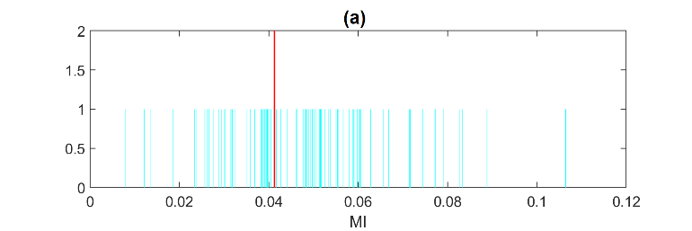

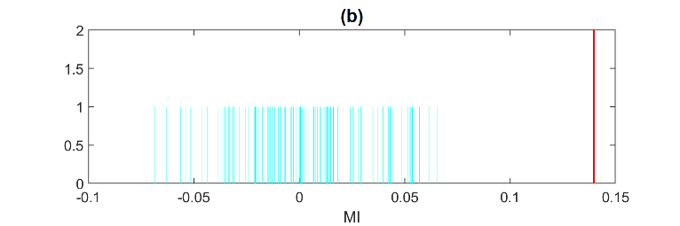

**Figure 1**: Randomization test of significance of mutual information (MI): no-rejection in (a) and rejection in (b).

The sections for acknowledgements and references should appear at the end of the abstract (Times New Roman 11pt font).

**Acknowledgements (optional)**

The acknowledgements should be written here. For assistance, you may contact DDE2025 organizers by email to ddeu2025@auth.gr.

**References (optional)**

[1] X. Author, Y. Author, Z. Author, *Scientific Reports*, 20 (2011) 537.

[2] X. Author, Y. Author, Z. Author, *Proc. of Solar Chemistry and Photocatalysis: Environmental Applications, Las Palmas de Gran Canaria*, Spain, 2006, 10.