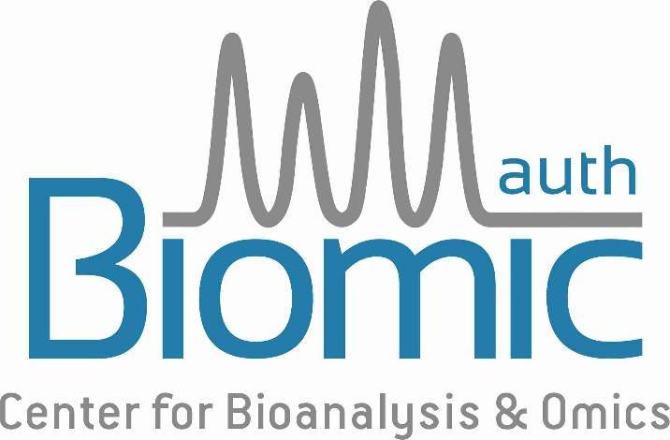

Application for Scholarship

APPLICATION SUBMISSION DEADLINE 10 MARCH 2025
Please send this form as EDITABLE DOC file (no other formats) to biomic@auth.gr

1. Personal Data

Last Name .......................................... First Name .............................................
E-mail ..................................................................................................................
Workplace address ………………………………..................………………………
ZIP Code ……......………… City ……......………………………………….............
Country ...............................................................................................................

2. Personal Statement
In no more than 100 words, explain what you hope to gain by attending the meeting

3. Title of your presentation

4. Are you interested to join the speed mentoring session sharing lunch break with two experienced metabolomics scientists?

